The Battle of Neighborhoods

IBM Data Science Professional Certificate - Capstone Project

*Opening a new Restaurant in Berlin, Germany*

SARANG KAPSE- June 2021

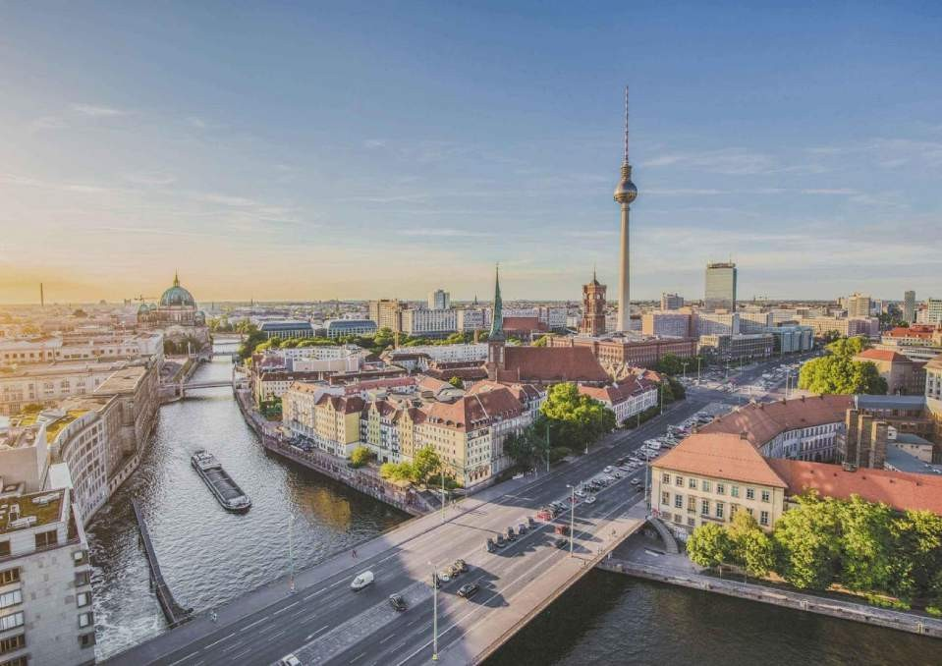

# Introduction

One of the most culturally and historically rich city in Europe, Berlin is famous for its food scene, coffee houses and good beer. Our hypothetical client, *XYZ Foods*, is a restaurant chain that runs a successful restaurant in South Africa. Their African restaurant, *XYZ Fine Dining* is a hit among the people and they want to start another branch of *XYZ Fine Dining* in Berlin.

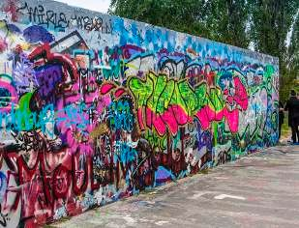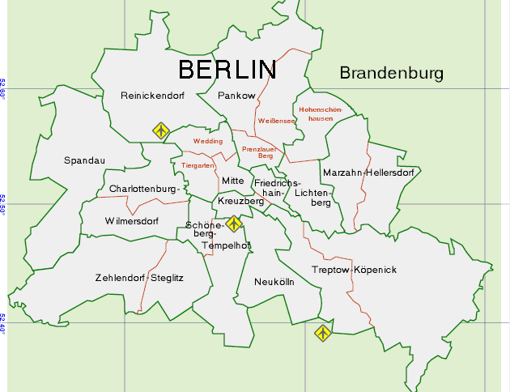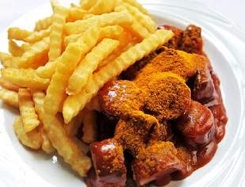

## Berlin: Rich in culture and food

**Business Problem:** The client is unable to decide which neighbourhood of Berlin would be best suited for the new chain of their African restaurant. The objective of this Capstone project is to analyse the various Neighborhoods of Berlin, Germany and select the best location for opening a new restaurant. In simple words, the business question this project aims at solving is: If someone is looking to open an African restaurant in the city of Berlin, where would you recommend that they open it?

**Target Audience**: This project is particularly useful for restaurant chain owners and/or investors looking to open and/or invest in an African restaurant in the capital of Germany.

# Data Requirements and Extraction

To solve this problem, we will need the following data:

* List of Neighborhoods in Berlin
* Latitude and Longitude coordinates of all the Neighborhoods
* Venue data (powered by Foursquare), particularly related to African Restaurants

**Sources of Data and Extraction Procedure:** The WikiPedia page of Boroughs and neighborhoods of Berlin list all the neighborhoods of the city. Using Web Scraping techniques, we will extract the required data, with the help of Python Requests and BeautifulSoup packages. The Python Geocoder package would be essential in finding the location data of these neighborhoods. At last, the Foursquare API would be used to extract the data regarding existing restaurants in the city.

In general, this project would be encompassing a series of Data Science techniques, including, but not limited to, Web Scraping (using BeautifulSoup and Requests), Data Cleaning, Data Wrangling and Machine Learning (K-Means clustering algorithm)

# Methodology

To get a list of neighborhoods in the city of Berlin. This data is extracted from the Wikipedia page titled, ‘Localities of Berlin’ *(https://en.wikipedia.org/wiki/ Category:Localities_of_Berlin).* Using the BeautifulSoup and Requests packages of Python, the required data is scraped from the webpage. In order to use the Foursquare API, we fetch the location data of all these neighbourhoods from the Python Geocoder package. Next, the Foursquare API is used to get the top 100 venues in a radius of 2000 meters of a particular neighborhoods. To prepare the data for K-means clustering, we group the data frame by neighborhoods. Lastly, K-means clustering in performed on this data set to return 4 clusters, or categories of neighborhoods in terms of number of African Restaurants.

# Results

The output from the clustering algorithm shows the division of all the neighborhoods into 4 groups in terms of number of African restaurants present in that area.

* Cluster 0: Neighborhoods with very low number of African restaurants
* Cluster 1: Neighborhoods with low number of African restaurants
* Cluster 2: Neighborhoods with a significant number of African restaurants
* Cluster 3: Neighborhoods with heavy competition of African restaurants The results are visualised as follows:

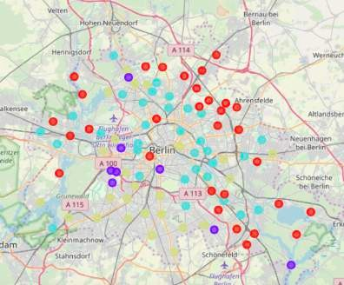Here,

Cluster 0 = Red Cluster 1 = Purple Cluster 2 = Light Blue Cluster 3 = Yellow

# Discussion

As observed from the clusters, opening a restaurant in Berlin could be tricky business. Going for Restaurants in Category 0 can lead to less footfall, but also non-existence of competition, hence, this is not recommended. On the other hand, Category 3 suffers from

an intense competition and this is also not recommended. African restaurants with a USP like innovative menu, dirt cheap prices etc. can go for Category 1 but Category 2 is recommended more than Category 1 due to a significantly higher expected target audience. Please check the Appendix for the complete list of neighborhoods divided into these categories.

# Limitations and Suggestions

Since Berlin isn’t an African city, nor are Africans a major ethnic group, tourism is a major part of the business of African Restaurants in the city. Due to unavailability of competent neighbourhood-based travel data, this factor couldn’t be taken into account in this project. Also, the clustering results highly depend on the accuracy of the Foursquare API. Lastly, since the API calls to the Foursquare API were made from a free Sandbox account, the results were limited. Data Scientists with a premium Foursquare account can overcome this bottleneck.

# Appendix

## Category 1: Neighborhoods with very low number of restaurants

|  |  |  |  |
| --- | --- | --- | --- |
| **63** | Niederschöneweide | 0.0 | 0 |
| **64** | Niederschönhausen | 0.0 | 0 |
| **65** | Nikolassee | 0.0 | 0 |
| **66** | Oberschöneweide | 0.0 | 0 |
| **67** | Pankow (locality) | 0.0 | 0 |
| **68** | Plänterwald | 0.0 | 0 |
| **69** | Prenzlauer Berg | 0.0 | 0 |
| **70** | Rahnsdorf | 0.0 | 0 |
| **71** | Reinickendorf (locality) | 0.0 | 0 |
| **72** | Rosenthal (Berlin) | 0.0 | 0 |
| **73** | Rudow | 0.0 | 0 |
| **74** | Rummelsburg | 0.0 | 0 |
| **75** | Schmargendorf | 0.0 | 0 |
| **76** | Schmöckwitz | 0.0 | 0 |
| **78** | Siemensstadt | 0.0 | 0 |
| **79** | Spandau (locality) | 0.0 | 0 |
| **80** | Staaken | 0.0 | 0 |
| **81** | Stadtrandsiedlung Malchow | 0.0 | 0 |
| **82** | Steglitz | 0.0 | 0 |
| **83** | Tegel | 0.0 | 0 |
| **84** | Tempelhof | 0.0 | 0 |
| **85** | Tiergarten, Berlin | 0.0 | 0 |
| **86** | Waidmannslust | 0.0 | 0 |
| **87** | Wannsee | 0.0 | 0 |
| **88** | Wartenberg (Berlin) | 0.0 | 0 |
| **90** | Weissensee (Berlin) | 0.0 | 0 |
| **91** | Westend (Berlin) | 0.0 | 0 |
| **92** | Wilhelmsruh | 0.0 | 0 |
| **93** | Wilhelmstadt | 0.0 | 0 |
| **94** | Wilmersdorf | 0.0 | 0 |
| **95** | Wittenau | 0.0 | 0 |
| **96** | Zehlendorf (Berlin) | 0.0 | 0 |

**Category 2: Neighborhoods with low number of restaurants**

**Neighborhood African Restaurant Category**

**19 Fennpfuhl 0.01 1**

**21 Friedenau 0.01 1**

**27 Gesundbrunnen (Berlin) 0.01 1**

**77 Schöneberg 0.01 1**

**89 Wedding (Berlin) 0.01 1**

**Category 3: Neighborhoods with a significant number of restaurants¶**

Neighborhood African Restaurant Category

1 Afrikanisches Viertel 0.011494 3

|  |  |  |
| --- | --- | --- |
| Borsigwalde | Moabit | Siemensstadt |
| Britz | Neukölln | Staaken |
| Fennpfuhl | Niederschöneweide | Wannsee |
| Friedrichshain | Niederschönhausen | Wedding |
| Frohnau | Pankow | Weissensee |
| Hakenfelde | Plänterwald | Karow (Berlin) |
| Hansaviertel | Prenzlauer Berg | Wilhelmstadt |
| Heinersdorf | Reinickendorf |  |

**Category 4: Neighborhoods crowded with restaurants**

|  |  |  |
| --- | --- | --- |
| Buckow | Lankwitz | Tegel |
| Charlottenburg-Nord | Lichtenrade | Tempelhof |
| Dahlem | Lichterfelde | Westend |
| Friedenau | Mahlsdorf | Wilmersdorf |
| Friedrichsfelde | Mariendorf | Wittenau |
| Gropiusstadt | Märkisches Viertel | Zehlendorf |
| Hermsdorf | Nikolassee | Kladow |
| Karlshorst | Steglitz | Mitte |